**Pre-Journal Notes**

Things to read:

* Selected sections of Chapter 12 from our A++ textbook:
  + Design Overview
  + Computer System Design
  + Motherboard and Associated Component Design
  + Storage Subsystem Design
  + Troubleshooting Overview
  + (Skimming through the section on individual troubleshooting steps may be useful, but you do not have to include this in your journal.)
* Optional Viewing: "A Beginner's Guide To Building A Gaming PC" (does not have to be included in the journal)

Guiding Questions (answer these in your journal entry):

* Based on the chapter, what are the three most important components to think about if you were building a computer for yourself? How about if you were building a computer for another family member?
* Think back to the last time you had to troubleshoot a problem with your computer. What steps did you follow? Did you follow a different set of steps than the book recommends, and if so, do you think following the book's steps would have worked out better or worse?

**1. Design Overview**

This section of the chapter explains the importance of understanding different computer components for technicians who design computers for various purposes. It uses the analogy that a car owner would like a mechanic who happens to actually know how to *design* cars to help with car maintenance/repair.

**2. Computer System Design**

This section describes popular/common/important components of computers for different purposes:

* CAM/CAD/Graphics Design
  + Powerful multi-core CPU
  + Max system RAM
  + Good video card, GPU, and max video RAM
  + High storage capacity
  + (Not as important but still important enough to list them)
    - Large/Dual display(s)
    - Possible peripherals such as tablets or 3d printers
    - Good input devices

* Gaming
  + Powerful multi-core CPU
  + High system RAM
  + Good video card, GPU, and max video RAM
  + High quality cooling system
  + Good storage capacity *(this wasn’t listed in Ebook but I would refuse to buy a gaming pc with poor storage, especially given the large sizes of modern games)*
  + Quality sound card
  + (Non-essentials)
    - Quality input devices
    - Quality headphones and/or speakers
    - Dual Monitors
    - Game console
    - VR headset
* Video/Audio Editing
  + Quality video card, GPU, and max video RAM
  + Quality sound card and speakers
  + Hard drive with high speed and capacity
  + Powerful multi-core CPU
  + High amount of system RAM
  + Dual Monitors *(??? why does the Ebook keep listing dual monitors? Seems unnecessary to me, but I guess I’m used to using a single monitor so my opinion is probably biased)*
* Virtualization
  + Virtualization can mean several things
  + Ebook definition: *“A computer that has multiple operating systems in a virtual environment in which one operating system has no interaction with the other operating system; they are independent of one another. A virtualization PC has multiple powerful multicore processors, maximum RAM, multiple fast large-capacity hard drives, 1Gb/s network connection, virtualization software, and a possible NAS”*
    - NAS = Network attached storage; it increases virtual storage capacity
  + Thin Client Workstations
    - Thin client computers generally use desktop virtualization, store data on a cloud server or remote storage, and do not have typical components like hard drives. They are mostly used by corporations.
    - Ebook definition: “*A type of computer that does not have all the ports and components (such as a hard drive) of a traditional PC”*
    - Should have the following:
      * Meets minimum requirements for the operating system
      * 1Gb/s network connectivity
      * Basic applications
  + Thick Client Workstation
    - Most typical computers that store data on the hard drive are thick client computers
    - Ebook definition: *“A business computer that has applications loaded on the local hard drive. Contrast with thin client”*
    - Should have the following:
      * Meets recommended hardware requirements for selected operating system
      * Meets recommended hardware and software requirements for running desktop applications

Others I didn’t want to get too into detail with:

* Home Theatre (HTPC)
  + Usually used for playing movies, videos, music
  + Video output more suited for TVs
  + Modern HTPCs generally use HDMI
* Home Servers
  + A personally owned server
  + Can function as a web server, print server, or file server, store backups of computers, and control devices and media streaming (???) while being accessible from different locations
  + Should have multiple RAID hard drives and 1Gb/s (1000Mb/s) NIC, and high RAM
* Industrial Computers
  + Vague term for computers used for specific purposes, such as kiosks, computers in enclosures, showroom computers, etc.
  + Should be able to withstand effects such as weather, potential thieves, customers who try to use them for their unintended purposes, wear from heavy use, etc.
* Mobile Computers
  + A computer which can be used portably
  + Laptops, tablets, etc.
  + Require a battery
  + An SSD is better for dropping concerns
  + “Sufficient RAM” is listed in the Ebook, but I feel that this is not specific/clear enough. A mobile computer should and will have a very different amount of RAM depending on how large and expensive it is. For example, a large gaming laptop will have more RAM than a small tablet.

**3. Motherboard and Associated Component Design**

* Different motherboards will offer different features
  + Different chipsets
    - Which type of RAM is supported
    - Amount of PCI lanes
  + Amount of USB ports
  + Video expansion slots
  + Integrated GPUs
  + Other stuff

**4. Storage Subsystem Design**

* consists of magnetic or flash tech for internal or external hard drives, flash storage (including SSDs), or optical drives

**5. Troubleshooting Overview**

* Backup data first if possible
* Consider many different things before making a move
  + Corporate policies, procedures, impacts
  + Resources such as documentation for computer components, corporate documentation, past experiences, training material, other technicians, customers, etc.
* Logical steps:

1. Identify the problem
2. Establish a theory of probable cause (question the obvious)
3. Test the theory to determine the cause
4. Establish a plan of action to resolve the problem and implement the solution
5. Verify full system functionality and, if applicable, implement preventive measures
6. Document findings, actions, and outcomes

**6. Guiding Question Answers**

1. Based on the chapter, what are the three most important components to think about if you were building a computer for yourself? How about if you were building a computer for another family member?

* For building a personal computer, I’d want at least 1TB of storage, 16GB of RAM (but more is preferable), and a CPU with at least 6 cores, such as an Intel i7
* For family members, I am not sure. All of my family members aside from my brother (who is knowledgeable about computer components and would never require my advice) use computers for tasks which are not resource-intensive, such as viewing and editing documents, accessing email and websites, etc. They don’t play any video games or use any special editing/design software. However, they tend to leave *many* different pages open (which has caused some issues in the past), so a good amount of RAM would be helpful. My parents have stored a lot of data on their computers over the years, so investing in a large storage size might also be useful. Although not an essential feature, their current PC has a large screen, so they might be more accustomed to using a wide display.

1. Think back to the last time you had to troubleshoot a problem with your computer. What steps did you follow? Did you follow a different set of steps than the book recommends, and if so, do you think following the book's steps would have worked out better or worse?

* I believe the last time I needed to troubleshoot something on my computer was when I discovered that the hosts file had been tampered with to block a mcafee website (a technique used to prevent security software from updating). I identified this issue when I was trying out a program called “security task manager,” which functioned as a normal task manager and also notified me of potential security issues. The program alerted me that something was wrong with my hosts file, so I opened it and read its contents. After pasting the text I found in the file online, I found that my hosts file didn’t look like most people’s did. After digging a little more, I was able to understand the purpose of the hosts file, and that my hosts file was blocking mcafee.com even though I had never edited the file myself. Eventually I figured out how to restore the hosts file to its original state. I don’t think that following the book’s steps would have greatly improved my problem-solving, because my process was already somewhat similar and I fixed the issue in the end anyway.

**7. Some Images:**

1. Home Server Diagram

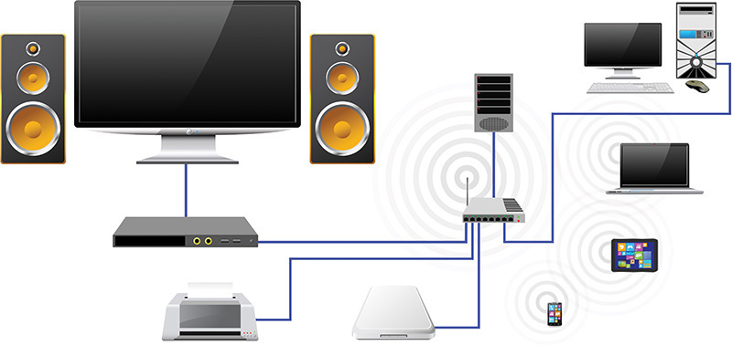

1. I *think* this might be a thin client workstation

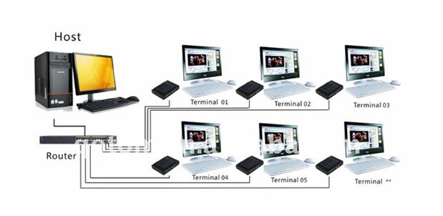

1. Storage Subsystem Design Considerations

